# Create Linux VM with AzureCLI less explicitly

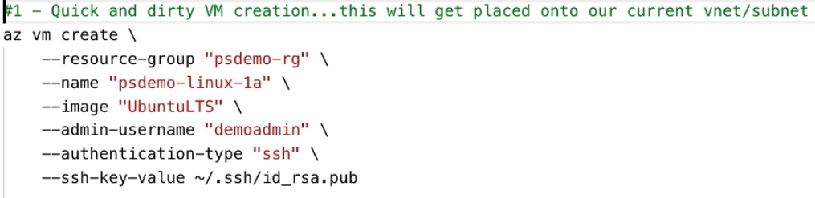

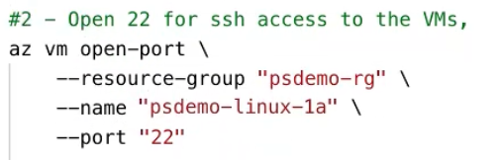

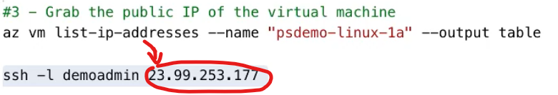

If trying to create a Windows VM:

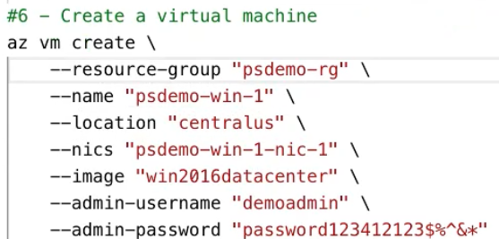

# Create Linux VM with PowerShell





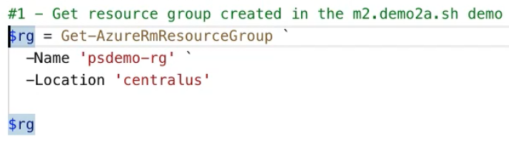

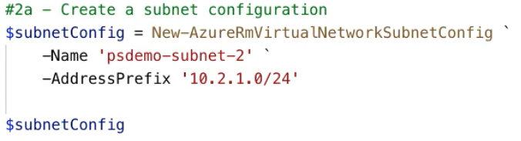

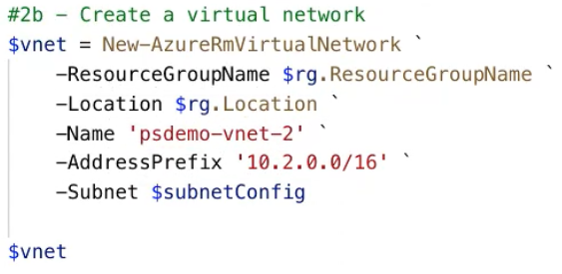

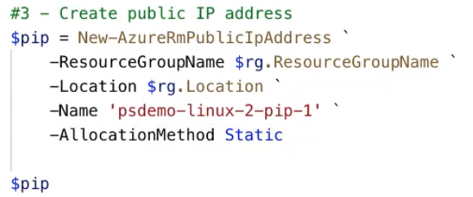

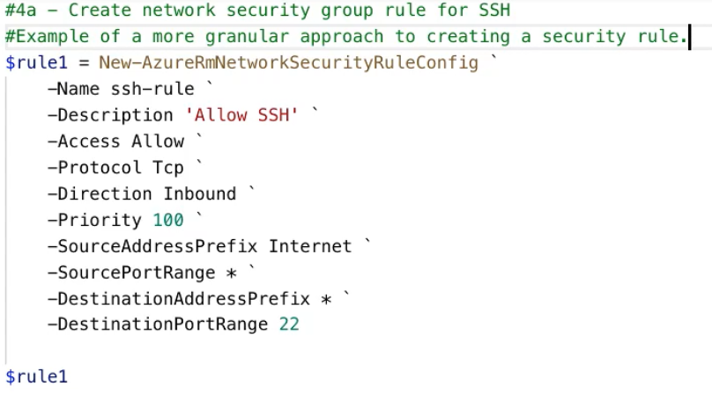

Previously we used the open port command: not with this.  
Priority: 100th (so if there’s a rule with Priority 101, it will get executed 1 later)

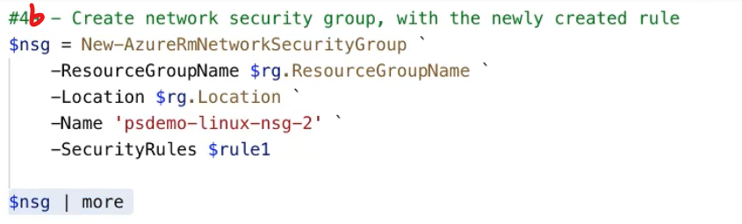

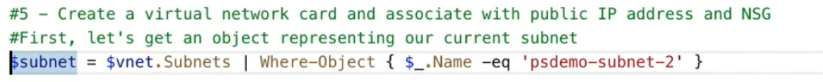

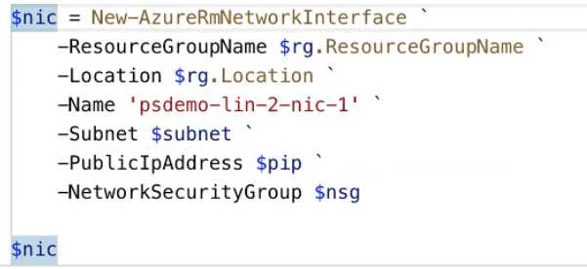

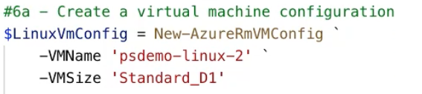



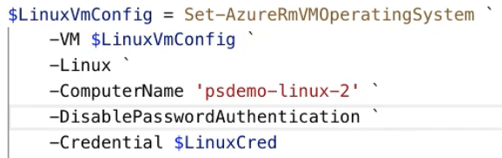

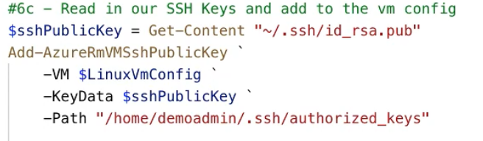

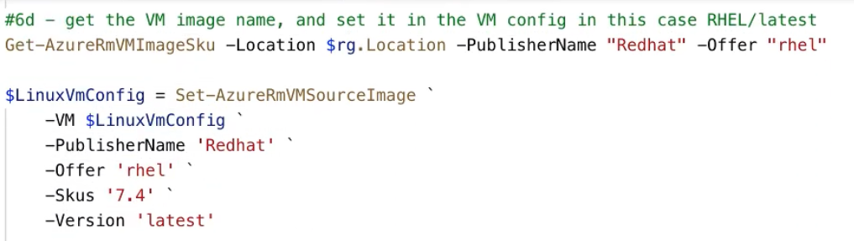

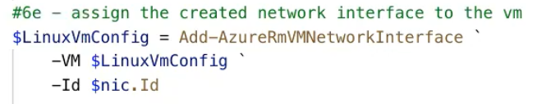

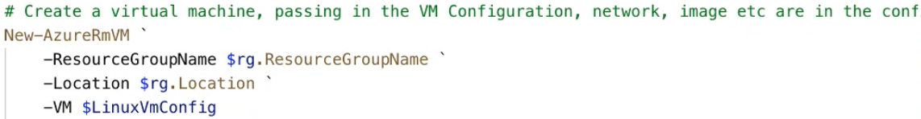

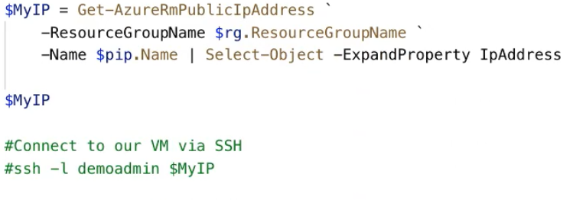

# Virtual Machine states

* Starting
* Running
* Stopping
* Stopped (still being charged, because it is allocated)
* Deallocating
* Deallocated

-AsJob parameter: PowerShell job, which is unblocking in the console

-Force: refresh state (some things are cached in the CLI/PowerShell/CloudShell)

**Get-AzureRmVm**

**Stop-AzureRmVm** –Force –AsJob *–StayProvidisioned*

...if StayProvisioned parameter is given, then VM is only stopped, NOT deallocated

**Start-AzureRmVm**

**Remove-AzureRmVm** (deletes VM all together, gone for good)